**CMPE_202 PROJECT**

**GRAPH COLORING**

I have gone through the activities in unplugged like Public Key encryption (http://csunplugged.org/public-key-encryption/#Kid_Krypto), Information Hiding(http://csunplugged.org/information-hiding/#Sharing_Secrets), Image Representation(http://csunplugged.org/image-representation/#Colour_by_Numbers) and Error detection(http://csunplugged.org/error-detection/#Card_Flip_Magic). Then as we met after the class and had discussion all have put their topic of interests. Then finally we had selected graph coloring as our project. Graph coloring can be implemented as a interactive multi player game. For this we need to create graphs first so to create graphs we are planning to make use of shapes like rectangle, circle, pentagon and so on. For example i have created one using paint

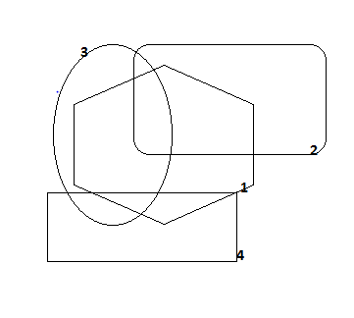

Here First I have drawn hexagon then on top of it have dropped rectangle number as 2. So hexagon is overlapped by rectangle 2. Then as a third shape I have used circle which overlapped both hexagon and rectangle. Finally I have dropped rectangle 4 on 1 and 2 . This is the basic idea to create a graph we must implement this using greenfoot. Then the user will be provided with at most five colors he must fill the shapes with colors such that adjacent shapes must not have same color. For example

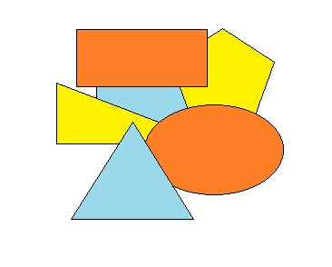

This is drawn using paint. Here I have used three colors seeing that adjacent shapes does not have same color. The user who makes use of less number of colors to fill the shapes in less time wins the game. Further we can consider background as also one object in such a case user must also fill background with a color. For example

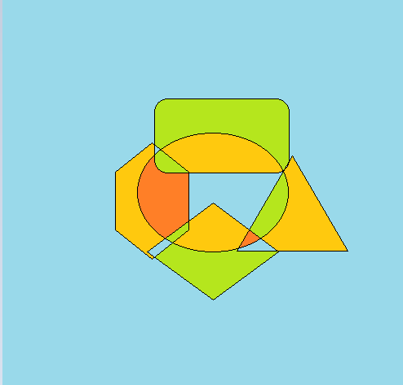

Here the background color is sky blue. Criteria here is all the shapes which share border with background must not have same color as background. Coming planning to start with UML diagrams for the same as discussed above.